Unreal Engine: Import object from Blender – Quick steps

First, set Blender world scale to “Metric”,

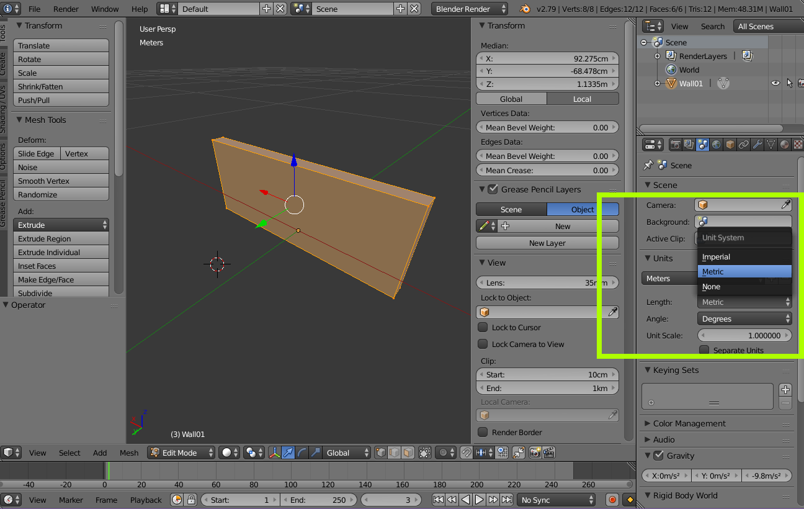

Then, design your model and just before exporting it, set “location, Rotation, Scale” of each objects by pressing Ctrl + A

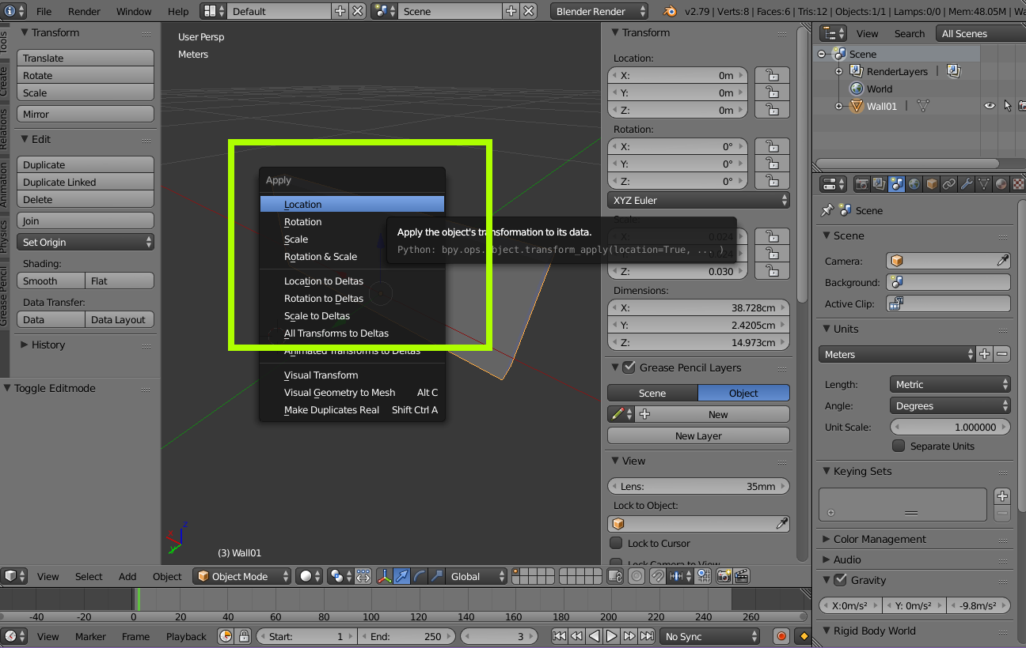

Don’t forget to tick all transforms

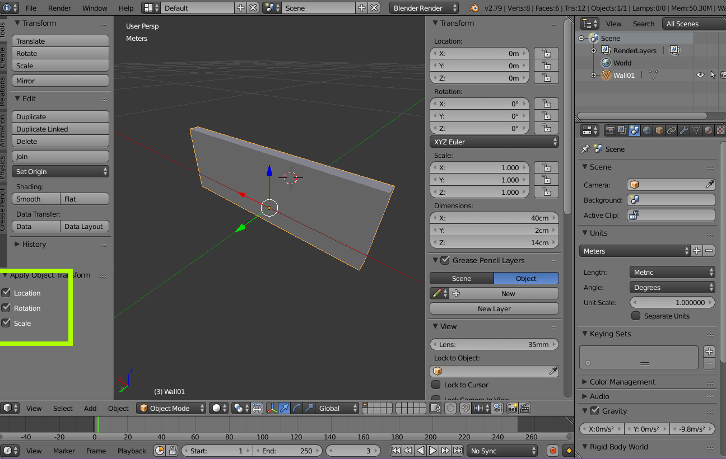

After that, in export to unreal, you need to use FBX and set Scale. (Unreal use Centimetre and Blender is on Metric).

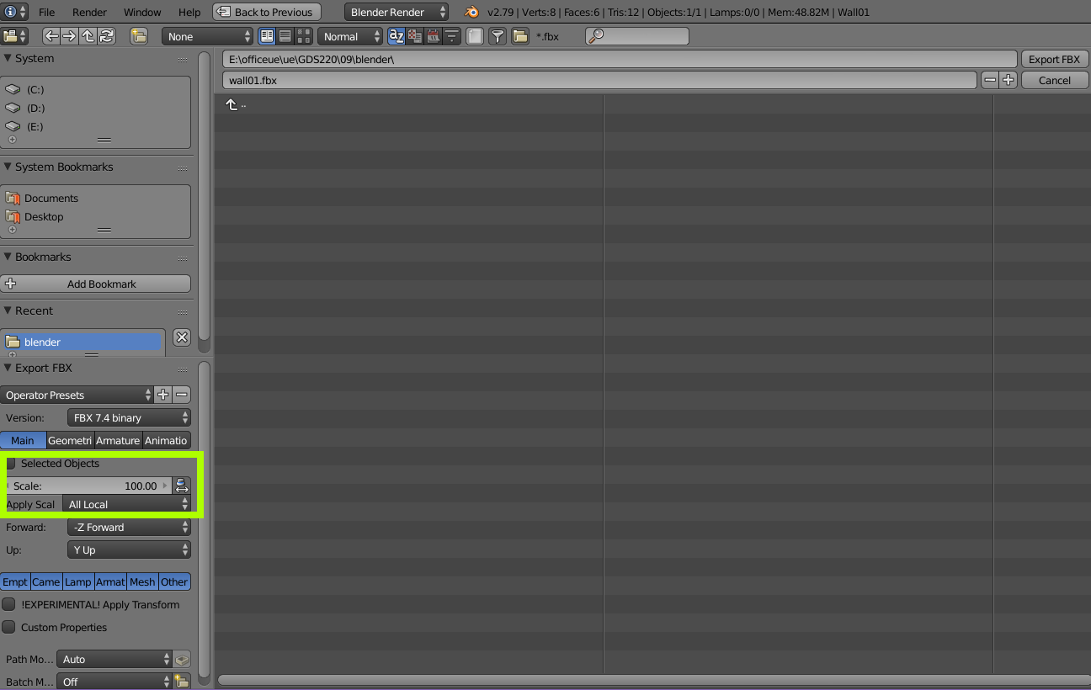

Now your model is ready to import in unreal.

There are 2 imported FBX objects from Blender in sample UE project with names “wall01” and “wall02”. First imported with scale = “100” and the other one imported by scale= “1”.

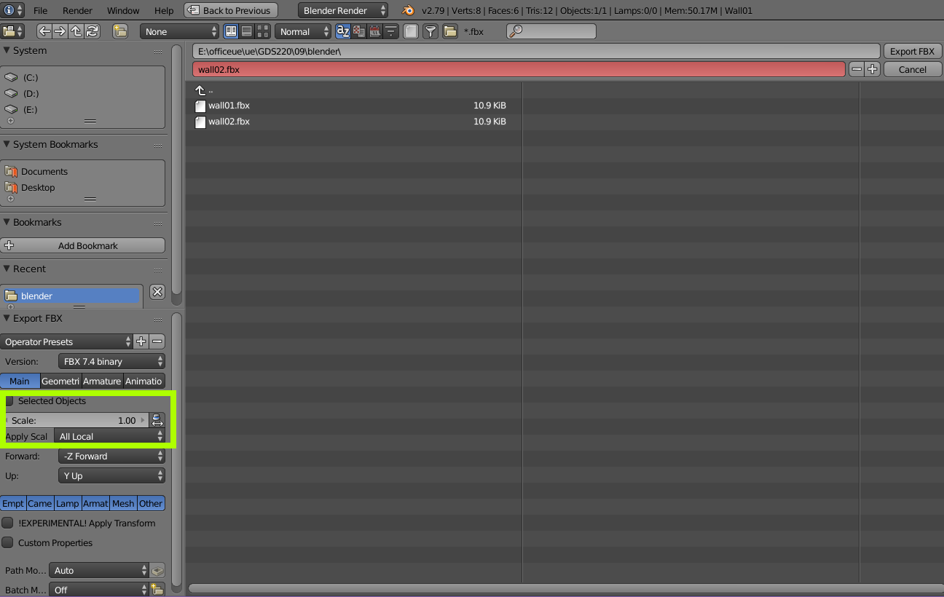

Using:

Blender 2.79  
Unreal Engine 4.20